**百味海南** **·人间至味**

**A Hundred Flavors of Hainan**

**百道海南菜**

主办单位：海南省商务厅

承办单位：海南省酒店与餐饮行业协会

英文审校：海南省外事办公室

Organizer: Department of Commerce of Hainan Province

Host: Hainan Provincial Hotel and Catering Industry Association

English Revision by: Foreign Affairs Office of Hainan Province

**海南菜：让世界爱上海南味**

海南菜，简称“琼菜”,为海南地方风味菜系。海南菜取材立足于海南 特产，鲜活为主。味以清鲜居首，重原汁原味，甜酸辣咸兼蓄，讲究清淡，菜 式多样，适应性较强。清鲜、清淡、原汁原味，是海南菜的最大特色。

海南素有“海产万类，陆产千名”的美誉。海南菜的烹技经历了两千多 年的发展历程，融会了闽粤沿海各省的烹饪之法，又吸收了黎、苗族等当地 原住民和居民的食习，还引进了东南亚风味，形成了食材丰富、特色鲜明、 风味百变的菜肴风格。

海南菜选材严格，注重新鲜、生鲜、生猛的食材。海南菜烹艺朴实，坚 持“最好的食材，用最朴素的烹技制作”的烹饪理念，多采用清蒸、清炒、 白切、白灼、清焖、清炖、鲜炸、香煎技法，保障了海南菜绿色、环保、养 生的生态特色和原汁原味及清鲜嫩爽的口味特点，形成了我国一支年轻而又 具有鲜明特色，颇具发展前景的地方菜系。

近年来，随着海南自贸港和国际旅游消费中心建设的不断推进，在海南 省政府行业主管部门的重视和推动下，海南餐饮业通过深度挖掘海南菜文化 内涵，培养海南菜烹饪专业人才，实施标准化建设，加大推广宣传力度，举 办各类美食交流活动，打造海南菜品牌美食IP, 在文昌鸡、加积鸭、和乐 蟹、东山羊这四大名菜基础上推出了海鲜糟粕醋、烤乳猪、温泉鹅、屯昌黑 猪等百道特色名菜，有力地推动海南菜快速发展，进一步提升了海南菜在国 内外的知名度和美誉度，海南菜已成为引领海南餐饮业高质量发展的重要力 量，成为展示海南风情、海南魅力、海南风范的一张靓丽名片。

**Hainan Cuisine: Let the World**

**Fall in Love with the Taste of Hainan**

Hainan cuisine, also known as "Qiong cuisine," showcases the distinctive culinary style of China's only tropical island province. Highlighting fresh, locally produced ingredients and their inherent qualities, it strikes a balance among sweet, sour, spicy, and salty flavors. The cuisine values simplicity while offering a wide variety of highly adaptable dishes.

Hainan has long been renowned for its abundant delicacies from both land and sea. For more than 2,000 years, Hainan cuisine has evolved by incorporating both techniques from coastal provinces like Fujian and Guangdong, and the dietary customs of local ethnic groups like the Li and Miao. Influences from Southeast Asia have further enriched this fusion, creating a distinctive culinary style with abundant ingredients and a diverse flavor palette.

Hainan cuisine emphasizes ingredient quality, prioritizing same-day freshness. Simple cooking techniques reflect the philosophy of combining the finest ingredients with the most straightforward methods. Common techniques, which include steaming, stir-frying, blanching, poaching, braising, stewing, frying, and pan-frying, embody a green, eco-friendly, and healthy approach to cooking, and help preserve the freshness and tenderness of the ingredients. While Hainan cuisine is a relatively new branch of Chinese cuisine, it has developed a distinct identity and has promising prospects.

In recent years, with the development of the Hainan Free Trade Port and the International Tourism and Consumption Center, the local food and beverage industry has intensified its exploration of Hainan’s cuisine culture. With strong support from local government agencies, the industry has trained professional chefs, implemented standardization, stepped up promotional efforts, and organized various culinary exchange events to cultivate distinctively Hainanese culinary brands. Building on "Hainan's Four Famous Dishes"—Wenchang Chicken, Jiaji Duck, Hele Crab, and Dongshan Goat—the industry has introduced new signature dishes like *Zaopocu (Dregs Vinegar)*, roast suckling pig, hot spring goose, and Tunchang black pork. These efforts have significantly boosted the rapid development of Hainan cuisine and greatly enhanced its domestic and international reputation. Hainan cuisine has become a significant driving force for the high-quality development of the local food and beverage industry and a vibrant showcase of Hainan's unique charm and cultural identity.

3





Classic Dishes of Hainan

**嘉积鸭椰子盅**

琼海嘉积鸭，相传是300多年前由华侨从马来西亚引进的良种鸭，故 称“番鸭”。海南四大名菜之一。此鸭散养于原生态的环境中，皮薄肉 厚，骨软、肉嫩、脂肪少、食之肥而不腻，营养价值高。

加积鸭椰子盅是一道极具地方特色的美味佳肴，选用优质的加积鸭， 将其与新鲜椰汁和椰肉一同放入椰子盅内文火慢炖。在炖煮过程中，椰汁 的清甜和鸭肉的鲜美相互交融，彼此成就。揭开椰子盅盖，香气扑鼻，汤 汁清澈，鸭肉入口即化。这道汤不仅味道鲜美，还具有丰富的营养，是滋 补身体的绝佳选择。

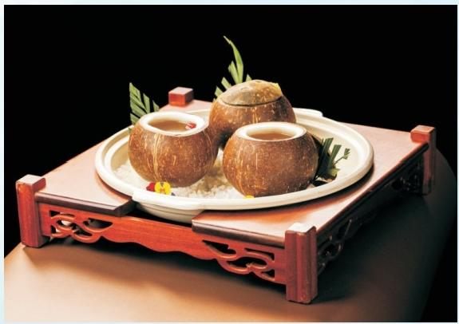

**Jiaji Duck Soup in Coconut Bowl**

Jiaji duck from Qionghai is a premium breed reportedly introduced from Malaysia by overseas Chinese over 300 years ago, hence its other name, "foreign duck." Counted among Hainan's Four Famous Dishes, Jiaji duck is raised free-range in nature. With thin skin, thick, tender meat, and soft bones, it is highly nutritious, low in fat, and has a rich but delicate flavor.

Jiaji duck soup in coconut bowl, a signature delicacy of Qionghai, features premium Jiaji duck slowly stewed in a coconut shell with coconut water and meat. During the stewing process, the delicate sweetness of the coconut water blends with the pleasant smell of the duck meat. When the lid is lifted, an irresistible aroma fills the air. The duck meat in the clear broth is so tender that it would almost melt in your mouth. Both delicious and wholesome, this soup is a perfect choice for health-conscious diners.





Classic Dishes of Hainan

**白切文昌鸡**

文昌鸡位列海南四大名菜之首，是极富盛名的海南美食头牌。清代 《岭南杂事诗抄》记载：“文昌县属有一种鸡，而若牧肉，味最美。”文 昌鸡鸡肉质极美，细嫩柔润有韧，本味淳美，尝之有淡淡鲜甜。

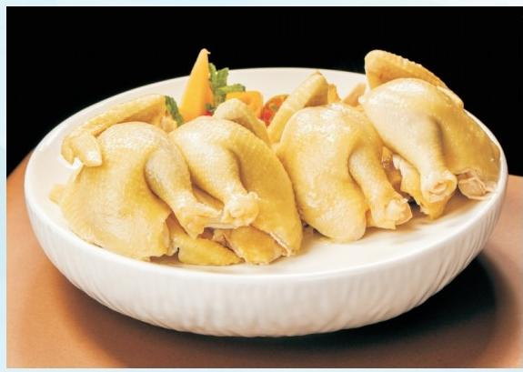

**Sliced Boiled Wenchang Chicken**

Wenchang chicken ranks first among Hainan's Four Famous Dishes and is the island's most celebrated culinary specialty. The Qing Dynasty work *Miscellaneous Poems of Lingnan* by Chen Kun records: "There is a type of chicken in Wenchang County with exceptionally tender meat and the most exquisite flavor." Wenchang chicken boasts incredibly delicious meat—tender, smooth yet firm, with a pure, natural taste and a subtle hint of sweetness.





Classic Dishes of Hainan

**盐煽东山羊**

海南东山羊产于海南万宁的东山岭，是海南四大名菜之一。《海南之 最》等书籍称，东山羊饲养繁殖始于明代，饮崖间泉水，息于岩峒中。据 传早在宋代，海南东山羊就列为皇室贡品。东山羊养生放养，食当地特产鹧 鸪茶等稀有草木成长，皮韧肉肥腴香浓，肥瘦相间软糯可口，不腻不膻。

盐煽东山羊是一道独具特色的美味。甄选的东山羊经过盐煽的独特工 艺，外表金黄诱人。羊皮略带韧性，羊肉鲜嫩多汁，肌理分明，入口咸 香，毫无膻味，只余醇厚的肉香。盐煽的独特风味深入每一丝纤维，越嚼越 香，令人陶醉。其口感丰富，是海南人餐桌上令人难以抗拒的美味佳肴。

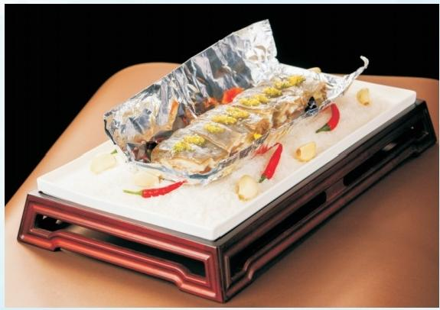

**Salt-baked Dongshan Goat**

Dongshan goat, raised on Dongshan Ridge in Wanning, is one of Hainan's Four Famous Dishes. According to records in *The Best of Hainan* and other books, the systematic breeding of goats on Dongshan Ridge began in the Ming Dynasty (1368-1644), with the goats drinking spring water from cliffs and resting in rocky caves. Even as early as the Song Dynasty (960-1279), goats from the area were offered as tribute to the imperial court. These free-range Dongshan goats feed on partridge tea and other local rare plants, resulting in rich and fragrant meat with a perfect balance of fat and muscle protected by a tough hide. When cooked, the meat is tender and delicious, neither greasy nor gamey.

Salt-baking is a uniquely delicious way of preparing this meat. Carefully selected goat meat is coated in salt and then baked, giving it a golden, enticing appearance. The process gives the rind a slight chewiness, while the meat is tender, juicy, and well-textured. The flavor is savory without a hint of gaminess—only a rich, robust, meaty taste. The salt from the baking process permeates every fiber of the meat, which becomes increasingly fragrant with each bite, creating an intoxicating experience. The rich texture of this dish makes it a highlight in the island's culinary repertoire.





Classic Dishes of Hainan

**和乐蟹肉卷**

和乐蟹位列海南四大名菜之一，来自海南万宁和乐镇小海，原生态生长 环境使之细嫩鲜美无比。和乐蟹蟹膏金黄粉质口感扎实，蟹钳肉质尤美，含 丰富的蛋白质与微量元素，养生滋补。

和乐蟹肉卷是一种令人惊艳的美食，轻咬一口，首先触碰到的是外层柔 软的外皮，接着蟹肉的鲜嫩质感在口中展露无遗，细腻且富有弹性，仿佛能 感受到蟹肉之间细腻的纤维。蟹肉的鲜美滋味瞬间在口腔中弥漫开来，带着 淡淡的清甜。整体口感外酥里嫩，鲜与香在每一次咀嚼中交融，让人回味无 穷，欲罢不能。

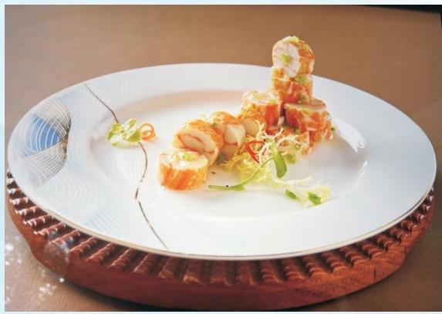

**Hele Crab Rolls**

Hele crab from the waters of the Xiaohai Lagoon in Hele Town, Wanning, is one of Hainan's Four Famous Dishes. Its pristine growing environment contributes to exceptionally tender meat. The crab's cream features a golden, powdery texture, while the meat in its claws is delectable and rich in protein and trace elements, making it nourishing and beneficial for health.

Hele crab roll is an exquisite delicacy. Its soft outer layer gives way to the tender, elastic texture of the crab meat as the teeth and tongue gently pull apart the fibers. An immediate burst of freshness and savory richness follows, spreading across the palate with a subtle sweetness. The overall texture is crispy on the outside and tender on the inside. Each bite blends freshness and flavor, leaving an unforgettable and irresistible aftertaste.





Classic Dishes of Hainan

**四更烤乳猪**

东方四更烤乳猪源远流长，据传已有300年的历史。四更烤乳猪之所 以能够深受欢迎与其原料和做法有着很大关系，四更烤乳猪采用的原料是 来自东方市四更村。其独特工艺经世代传承，声名远扬。多年来，凭借皮 脆、肉嫩、骨酥、味香的特色，深受食客欢迎，流传至今，成为东方美食 的一张亮丽名片。

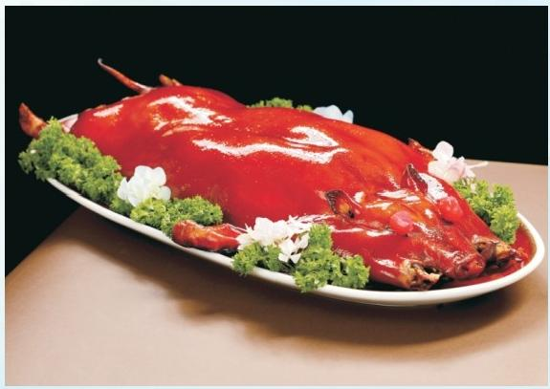

**Sigeng Roast Suckling Pig**

Sigeng roast suckling pig has a long history dating back over 300 years. Its popularity is primarily attributed to its quality ingredients and meticulous preparation method, with the pigs sourced from Sigeng Village in Dongfang City. The unique craftsmanship behind the dish has been passed down through generations, earning widespread acclaim. For years, it has been beloved by diners for its crispy skin, tender meat, edible bones, and rich flavor. It thus remains a shining symbol of Dongfang cuisine.





Classic Dishes of Hainan

**油泡海南小青龙**

新鲜优质的小青龙(虾)来自海南优质水质海域，色泽鲜亮，壳薄如 翼，虾肉鲜甜莹润如玉，原汁原味，鲜美浑然天成。

油泡海南小青龙是一道令人垂涎的美味。小青龙经热油泡制，色泽鲜 红亮丽，诱人食欲。虾肉饱满紧实，富有弹性，入口鲜嫩爽滑。油泡的烹 饪方式锁住了虾肉的鲜美，同时增添了独特的油香。轻轻咀嚼，虾肉的清 甜在舌尖上散开，口感醇厚，余味悠长。无论是视觉还是味觉，这道菜都 给人带来极大的满足，让人难以忘怀。

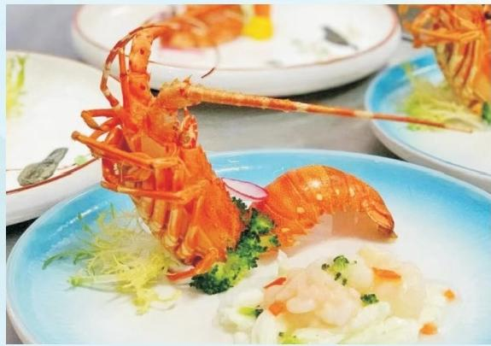

**Oil-steeped Hainan Spiny Lobster**

Brightly colored and with thin shells, premium spiny lobsters in the pristine waters of Hainan boast sweet and tender meat, providing an authentic and naturally delicious taste.

Hainan spiny lobster is a mouthwatering delicacy. Steeped in hot oil, the shell turns bright red and glossy, a sight that stimulates the appetite. This cooking method makes the meat plump, firm, elastic, and tender with a smooth texture. It locks in the freshness of the meat, while taking on a unique aroma. With each bite, the delicate sweetness unfolds from the tip of your tongue, delivering a lingering aftertaste. Whether seen or tasted, this dish brings great satisfaction and leaves an unforgettable impression on the beholders.





Classic Dishes of Hainan

**五指山酸汤鱼**

五指山酸汤鱼是五指山市特有的民族佳肴，五指山酸汤鱼的酸味独 特，来源于食叶草自带的酸味，与鱼肉融合后，形成一种草本的自然味 道。这道菜的味道醇厚，口感滑嫩，适口性极强，深受食客喜爱。

食叶草是一种具有高蛋白、高氨基酸含量的植物，富含多种人体所需

的营养元素，其味道酸酸的，为酸汤鱼提供了独特的酸味。

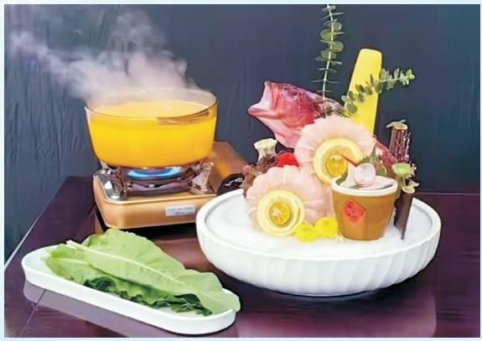

**Wuzhishan Sour Fish Soup**

Wuzhishan sour fish soup is a unique ethnic delicacy of Wuzhishan City. Its distinctive sourness comes from the natural acidity of the patience dock leaves, which blends harmoniously with the fish to create an herbal, refreshing flavor. This dish boasts a rich taste and tender and smooth texture, making it a local favorite.

Patience dock (*Rumex patientia*) is rich in protein, amino acids, and other various nutrients essential for human bodies.

The oxalic acid contained in its leaves provides the unique sour flavor characteristic of this soup.





Classic Dishes of Hainan

**琼味烹带皮小黄牛**

五指山号称“海南之心”,周围群山环抱，森林茂密，至今保留着浓 郁的黎苗民族风情。五指山的小黄牛享有“肉中骄子”之美称，散养于热 带雨林中，嚼食奇珍草木生长，肉质细嫩鲜润，纤维细嫩浑然天成。

琼味烹带皮小黄牛的口感堪称一绝。牛肉入口，首先感受到的是皮的 软糯Q弹，富含胶质感。鲜嫩多汁的牛肉，纹理分明，紧致而不绵柔。焖 制的独特风味充分渗透其中，咸香适中，每一口都充满浓郁的肉香，让人 唇齿留香，回味悠长，是舌尖上的极致享受。

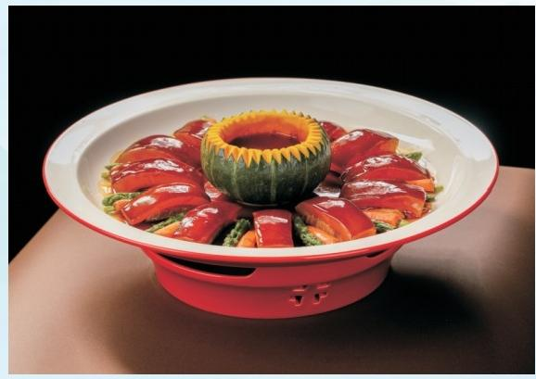

**Red-braised Hainan Yellow Cattle Beef with Rind**

Wuzhishan, known as the Heart of Hainan, features mountains and dense rainforest, which have helped preserve the rich and varied customs of the Li and Miao ethnic groups. Yellow cattle from this area are hailed as "the finest of meats". Raised free-range in the tropical rainforest, they feed on rare vegetation, resulting in naturally tender meat with a fine texture.

The flavors of red-braised Hainan yellow cattle beef with rind are truly unparalleled. The first bite reveals the soft, sticky, chewy texture of the rind, rich in gelatin. The tender and juicy flesh showcases distinct marbling and holds together well. The unique flavor permeates throughout, offering a balanced savory taste. Each bite is filled with a rich, meaty aroma, leaving a lingering aftertaste. This dish is a veritable delight for the palate.

11





Classic Dishes of Hainan

**黄椒酱蒸龙胆鱼**

海南美食之美，在于鲜。黄椒酱蒸龙胆鱼，黄椒酱的辣味与龙胆鱼的 鲜美形成了鲜明的对话，却又是彼此交融，是一道令人惊艳的佳肴。新鲜 的龙胆鱼在黄椒酱的映衬下，色泽诱人。黄椒酱独特的辛辣与鱼的鲜美完 美融合，热气腾腾中散发出迷人香气。鱼肉鲜嫩多汁，入口即化，细腻的 口感中透着黄椒的辛辣刺激。每一口都充满了阳光与大海般浓郁的味道， 辣而不失鲜的原味，令人食欲大增，是餐桌上备受欢迎的美味。

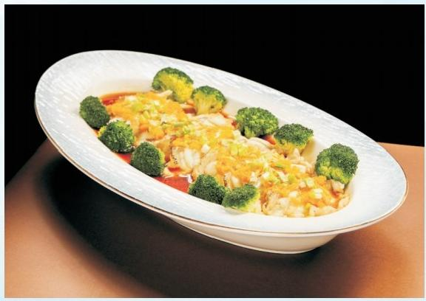

**Steamed Giant Grouper with Yellow Pepper Sauce**

Freshness is the soul of Hainan cuisine—especially in steamed giant grouper with yellow pepper sauce, where fish’s gentle sweetness meets the lively heat of the sauce, blending into a bold yet harmonious balance of flavors. The dish is a feast for the eyes with golden sauce gleaming atop the white flesh. The peppery fragrance complements the fish's briny scent, releasing an inviting aroma when served steaming hot. The flesh is tender and juicy, melting easily on the tongue. With the strong ocean-fresh taste neutralized by the pepper’s heat, each bite whets the appetite and reminds diners of the sunshine and the sea, making the dish a beloved delicacy in Hainan.





**糟粕醋小海鲜**

糟粕醋是文昌市铺前镇的一种传统小吃，是海南海边生活人民智慧的 结晶。糟粕醋采用民间酿酒过程中产生的酒糟发酵产生的酸醋作为汤料， 外加小海鲜烹饪的一种小吃。辅料配以辣椒、糖、蒜末等，味道微辣酸甜 可口。糟粕醋小海鲜口感层次极为丰富，汤汁酸而微辣，带着独特的酒糟 芳香，入口瞬间唤醒味蕾。海鲜的鲜嫩在糟粕醋的浸润下更显迷人，虾肉 紧实弹牙，贝肉爽滑鲜美。各种食材完美融合，酸味开胃，辣味提香，每 一口都充满惊喜，令人欲罢不能，回味悠长。

Classic Dishes of Hainan

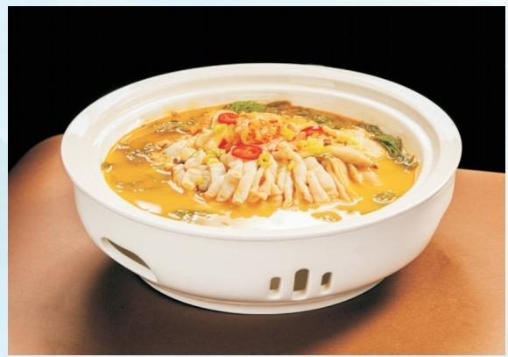

**Seafood *Zaopocu***

Seafood *Zaopocu* is a traditional dish from Puqian town, Wenchang, a testament to the culinary wisdom of Hainan's coastal communities. Zaopocu is a vinegar fermented from distiller's grains (a by-product of traditional winemaking). It is used as a broth base to cook an assortment of seafood. Seasoned with chili peppers, sugar, minced garlic, and other ingredients, the broth delivers a mildly spicy, sweet-and-sour flavor. The dish offers complex, layered textures—the tangy broth carries a subtle chili kick and a distinctive fermented aroma that instantly awakens the palate. Soaked in this broth, the tenderness of the seafood becomes even more enticing, with the shrimps firmer and the shellfish silkier and more succulent. As a whole, all elements blend perfectly: the sourness whets the appetite and the heat lifts the aroma. Every spoonful brings a fresh surprise and leaves a lasting aftertaste.





Classic Dishes of Hainan

**清炒海南菜心**

清炒海南菜心，带来清新的味觉享受。菜心色泽翠绿，鲜嫩欲滴。入 口爽脆，纤维细嫩。淡淡的青菜香萦绕齿间，凸显其天然之纯粹。简单的 烹饪保留了菜心的原汁原味，每一口都是大自然的馈赠。清爽解腻，营养 丰富，无论是单独品尝还是搭配其他菜肴，都能让人感受到海南菜心的独特魅力。

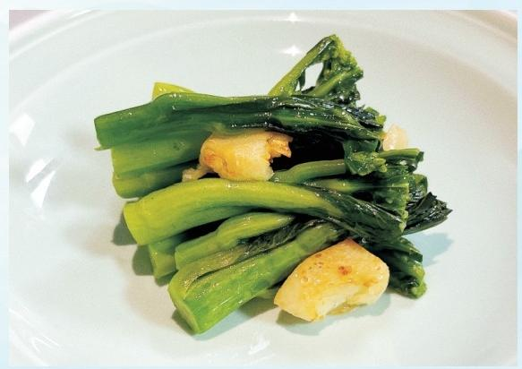

**Stir-fried Hainan Choi Sum**

Stir-fried Hainan choi sum offers a simple yet refreshing taste experience. The emerald-green stalks are cooked to a tenderness with a satisfying crunch at the first bite. The subtle leafy aroma lingers on the palate, highlighting the natural goodness of the vegetable. The simple cooking method preserves the original flavor of the choi sum. Each bite is a gift from nature. Refreshing and nutritious, this dish stands out for its simple charm, whether served on its own or alongside other delicacies.



**特色小吃拼时令水果**

糯米粿：是海南特色的传统美食。糯米粿外观圆润可爱，色泽洁白如雪。它由 优质糯米制作而成，口感软糯且富有嚼劲。内馅丰富多样，有甜口的椰丝、花生碎 和红糖。一口咬下，米香与椰子等馅料的香味融合，滋味美妙。无论是作为日常点 心还是节日美食，海南糯米粿都承载着浓浓的家乡味道，深受人们喜爱。

斑斓糕：海南美食以纯天然食材著称，斑斓糕由海南野生斑斓叶制成，叶之精华

与糯米融合，搭配椰浆的浓郁，碧绿晶莹，精致清爽，轻咬一口，清香盈满味蕾。

时令热带水果：海南具有得天独厚的气候条件、优质的土壤和水质，盛产具有海 岛特色的热带水果，莲雾、兴隆小米蕉、琼中绿橙、青枣、菠萝等水果都是新鲜美味 和健康养生之选。



Classic Dishes of Hainan

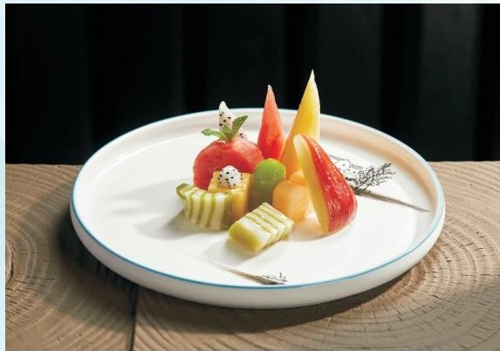

**Specialty Desserts and Seasonal Tropical Fruits**

Glutinous rice cake: a traditional Hainan delicacy. The round, snow-white cakes are made from premium glutinous rice, yielding a soft yet chewy texture. The fillings vary—from shredded coconut meat, to crushed peanuts, and brown sugar. Biting into one brings the glutinous exterior and sweet interior together in perfect harmony. For Hainanese, the simple treat carries the comforting taste of home. It is relished both as a daily snack and a festive delicacy.

Pandan cake: A testament to Hainan’s love for all-natural ingredients, the cake is made with wild Hainan pandan leaves and glutinous rice batter. The use of coconut milk adds to the creamy texture. The jade-green hue makes it visually appealing. The cake features a delicate and refreshing taste that fills the palate.

Seasonal tropical fruits: Blessed with a unique climate, fertile soil, and pristine water, Hainan produces an abundance of fresh, tasty and healthy tropical fruits, including wax apples, Xinglong mini bananas, Qiongzhong green oranges, jujubes, pineapples, etc.